
RAMAIAH
Institute of Technology
USN | 1 | M | S

(Autonomous Institute, Affiliated to VTU)
(Approved by AICTE, New Delhi & Govt. of Karnataka) Accredited by NBA & NAAC with ‘A’ Grade

SEMESTER END EXAMINATIONS – JANUARY 2019
Course & Branch | : | B.E: Electrical and Electronics Engineering | Semester | : | VII
Subject | : | Digital Image Processing | Max. Marks | : | 100
Subject Code | : | EEE24 | Duration | : | 3 Hrs

Instructions to the Candidates:
- Answer one full question from each unit.

 |  | UNIT- I
1. | a) | Write short note on sampling and quantization. | CO1 | (10)
 | b) | Transmission is occupied in packets consisting of a start bit, a byte of information and a stop bit,  - How many minutes would it take to transmit a 1048×1048 image with 256 intensity levels using 25.6K baud modem?  - What would the time be at 2500K baud? | CO1 | (06)
 | c) | Let p and q be the pixels at coordinates as shown in image segment shown in 2b). Find out which distance measure gives the minimum distance between pixels. | CO1 | (04)
2. | a) | Explain the fundamental steps involved in digital image processing. | CO1 | (10)
 | b) | For V={1,2} compute the length of shortest 4,8,m path between p & q in the following image shown in image 2b). Repeat the same for V={0,1} | CO1 | (06)
  5 | 4 | 3 | 1 | 1q
  5 | 4 | 0 | 2 | 0
  3 | 2 | 0 | 2 | 4
  2 | 1 | 1 | 3 | 5
  P1 | 3 | 5 | 1 | 3
 |  | Fig: image 2b)
 | c) | Find the time required in seconds for transmitting a monochrome image of size 2.5”×2” scanned at 150DPI and to be sent at 28 kBPS. | CO1 | (04)
 |  | UNIT- II
3. | a) | Recall the following point processing techniques with suitable example  - Brightness modification (ii) Log transformation | CO2 | (06)
 | b) | Suppose for an 8 level image , the prequance table for input grey level as shown in table 3 c , perform histogram stretching to fit the image from 0-7. | CO2 | (08)
 | c) | Suppose for a 8 level image, frequency table for input gray level are  Table 3 c  Perform Image Equalization on this image and plot input and resultant Histogram. | CO2 | (06)
  rk | 0 | 1 | 2 | 3 | 4 | 5 | 6 | 7
  nk | 0 | 0 | 3 | 5 | 2 | 8 | 0 | 0
4. | a) | With a block diagram bring out the fundamental principle of pseudo color image processing. | CO2 | (06)
 | b) | With suitable expression, discuss contrast stretching of image enhancement. | CO2 | (06)
 | c) | Reconstruct an image using 6,7, and 8th Bit planes of the following 8 bit image, also mention the importance of the bit-plane.  Fig. 4 (c) | CO2 | (08)
  0 | 1 | 3 | 5
  50 | 95 | 150 | 200
  110 | 150 | 190 | 210
  175 | 210 | 255 | 255
 |  | UNIT- III
5. | a) | Bring out the differences between spatial domain and frequency domain image enhancement approaches. | CO3 | (06)
 | b) | For the pixel (3,3) on image segment shown in image 5b) apply i) smoothing filter, ii) weighted average filter, iii) median filter, iv) min filter, v) max filter, vi) midpoint filter of size 3×3 , 5×5 and laplacian filter only 3×3 (4 connectivity & 8 connectivity). | CO3 | (14)
  10 | 11 | 12 | 11 | 10
  12 | 12 | 13 | 5 | 4
  13 | 12 | 5 | 3 | 5
  13 | 12 | 4 | 3 | 5
  12 | 4 | 3 | 4 | 4
 |  | image 5b)
6. | a) | Discuss characteristics of high boost filter in frequency domain. Explain how high boost filtering increases the enhancement of the images. | CO3 | (10)
 | b) | Suggest typical derivative for image enhancement:  i) Roberts ii) Prewitt iii) sobel. | CO3 | (10)
 |  | UNIT- IV
7. | a) | With an example, explain the concept of Edged based segmentation technique. | CO4 | (08)
 | b) | Explain Laplacian of Gaussian (LoG) filter. | CO4 | (06)
 | c) | Explain the image segment given in fig. 7(c) seed points are given at(3,2) and (3,4),similarity criterion is grey level difference.  Find segment image i) if T=3 ii) if T=8  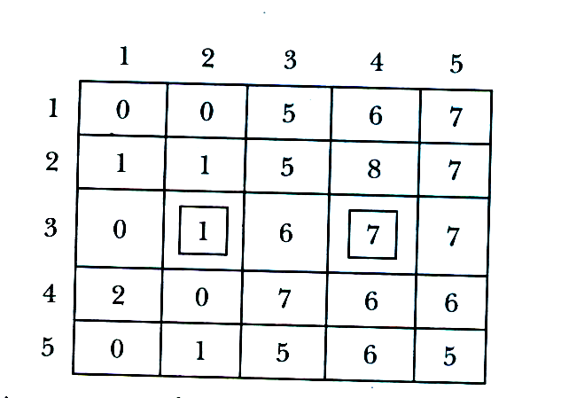  Fig. 7(c) | CO4 | (06)
8. | a) | With an illustration, explain splitting and merging algorithm of region based segmentation. | CO4 | (04)
 | b) | Give 3X3 prewitt and sobel masks that are optimized for lines at  +45 degree and -45 degree angle. | CO4 | (06)
 | c) | Explain the adaptive thresholding used in image segmentation. | CO4 | (10)
 |  | UNIT- V
9. | a) | U=[1 1 1 1  1 1 1 1  1 1 1 1  1 1 1 1], find forward and inverse DST. | CO5 | (08)
 | b) | Find 8×8 Haar transform matrix. | CO5 | (12)
10. | a) | Prove that it needs O(Nlog₂N) operations for Hadmard transform. | CO5 | (10)
 | b) | Compute i) 2D DFT and ii) 2D DCT of given 4×4 grey scale image:  U=[1 1 1 1  1 1 1 1  1 1 1 1  1 1 1 1] | CO5 | (10)

****************

